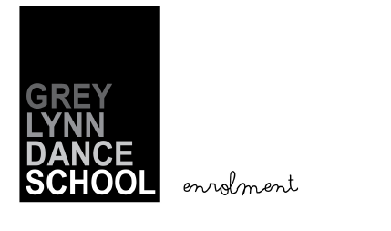

Student’s name ……………………………………………………………………………

Student’s date of birth ……………………………………………………………………………

Parent / guardian’s name ……………………………………………………………………………

Postal address ……………………………………………………………………………

…………………………………………………………………………….

…………………………………………………………………………….

Email address …………………………………………………………………………….

Telephone (home) …………………………………………………………………………….

Telephone (mobile) …………………………………………………………………………….

Please be aware that dancers perform at their own risk and neither I nor my studio will accept any responsibility for accident or injury to dancers in attendance at the studio. This condition also covers parents and/or spectators.

I accept these conditions……………………………………………… .……………..
Parent or Caregiver Date

Grey Lynn Community Centre, 510 Richmond Road, Grey Lynn T (09)818 5536 E greylynndanceschool@gmail.com
Fb GreyLynnDanceSchool

